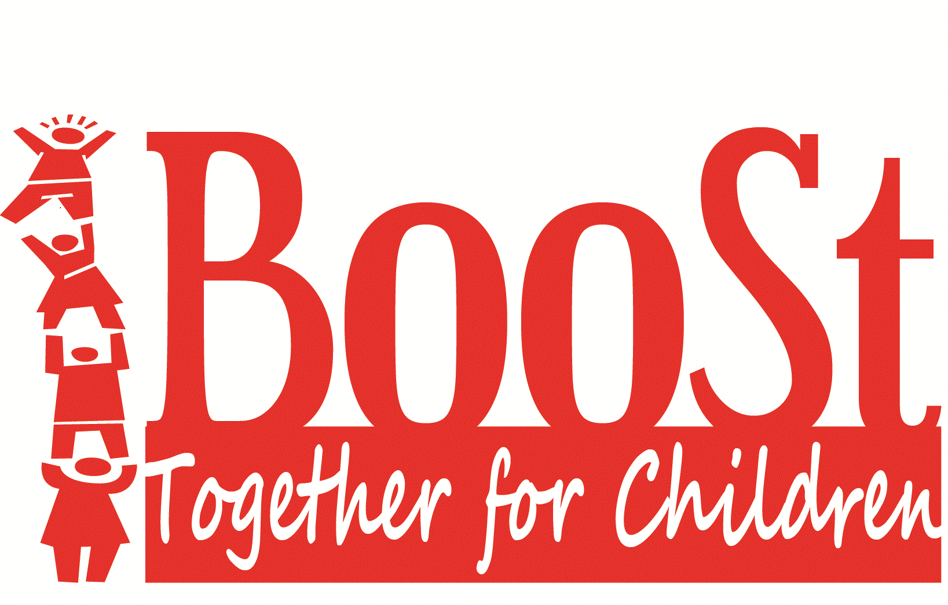
Board of Directors Meeting Minutes
November 1, 2022 5:30 to 6:30 PM
Location: Story County Human Services Bldg., 126 S. Kellogg Ave Ames IA
Meeting called to order: 5:32pm

Members in attendance: Eric Gebhart, Lynn Chitty, Kris Gross, Latifah Faisal, Jack Friend
Executive Director-Anita Claman
Members absent: Celeste Mortvedt, Abbie Schaffer & Wilma Pillot
Members of the public: Gina Wells & Christa Jergins-CCR&R, Peg Ragner-YSS, Janet Horras-IDPH, Alissa Barton-LSI
On Zoom Amanda McKee-LSI and Jennifer Schmidt-YSS

Adoption of Agenda with the addition of minutes from October 11, 2022 moved by Chitty, Second by Friend | MCU
Review and approve minutes from September 13, 2022 and October 11, 2022 with corrections Moved by Gross, second by Chitty | MCU
Public Forum
- Ms. Ragner reported that YSS is looking to schedule additional Assist training in January
- Ms. Wells reported a very good turnout for the fall preschool conference with 32 in attendance
- Ms. Barton reported that Beloit campus was sold 2 weeks ago. They need to be moved out by January 9, 2023. They are looking for new space

Board Processing Committee report
Reviewed: BYLAWS of The Association of Early Childhood Iowa Area Boards and Advocates to Vote on a Delegate to represent board. Made recommendation to designate ED Anita Claman as delegate.
Children Service Committee report
- Reviewed State Family Support Programs Report.
- Reviewed and approving BooSt Grant Proposal for FY23
- Reviewed Quarterly Reports and DAISEY information.
New Business  - Motion by Friend to designate Anita Claman to represent BooSt Together for Children as voting delegate for the Association of Early Childhood Iowa Area Boards and Advocates. Second by Chitty  - Janet Horras State of Iowa Department of Public Health Home Visitation Director presented on and reviewed BOOST FY22 Family support data. Comments and recommendations in the report: “Several programs have pink color coded performance indicating lower than expected performance compared to the target. Several programs also have green color-coded performance indicating performance targets met or exceeded. Low educational attainment, low income and parenting alone are three significant indicators of risk. There were no incidents of obvious data errors as mentioned in the limitations remarks for any of these programs. The Story and Boone County NEST programs appears to be out of adherence with Tool FF developmental screening requirements. Both of the Boone County home visiting programs are serving very small numbers of families. The board may want to consider only funding one program to eliminate competition and duplication between two very small programs. The Healthy Futures program in both counties is providing a lower than expected number of home visits resulting in averages that are less than the state average for similar services.” Reviewed importance of Tool ff as well as specific outcome data | MCU
Old Business:
- Dad’s Boot Camp: Parent Training class for fathers requesting start up funding. Motion approved by board.
Mileage Reimbursement in accordance with State of Iowa Department of administrative Services was approved at an increase of .50 cents per mile from .39 cents per mile.
Directors Report:
- ED Claman reported on activities in October and upcoming in November:
- Meeting with Northwood principal on possible collaborations
- Meeting with another Carrie Sodders director Head Start and to discuss Head Start and Child Care staffing and COVID-19 recovery
- Contractor site visits beginning in December
- Ms. Claman has continuing DHS training through December (approximately 20 hrs of CEU’s)

Presentation by Special Guest: YSS Healthy Futures

Next Board Meeting: December 13, 2022
5:30pm brief reception
6:00pm meeting begins

Location: Story County Human Services Center, 126 S. Kellogg Ave. Ames IA and Zoom
Presenter: David Ahrens: State Early Childhood Iowa Board Member
Presenting Program: YSS Stork NEST

Adjournment of board meeting 7:00pm: moved by Chitty, second by Gross

The Americans with Disabilities Act requires BooSt to make reasonable accommodations for all individuals to attend meetings. Call 515-433-4892 or email: aclaman@boonecounty.iowa.org

