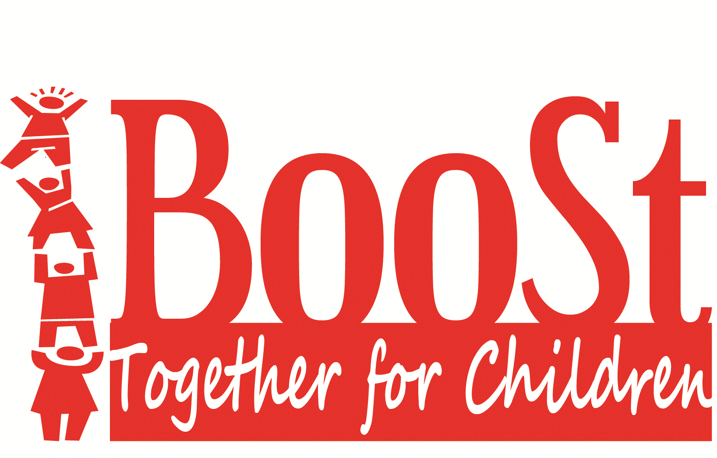
Board of Directors Meeting Minutes
December 13, 2022 5:30 to 6:30 PM
Location: Story County Human Services Bldg., 126 S. Kellogg Ave Ames IA
Meeting called to order: 5:37pm

Members in attendance: Jack Friend, Kelly Polich, Kris Gross, Latifah Faisal, Abbie Schaffer
Executive Director-Anita Claman
Members absent: Eric Gebhart, Celeste Mortvedt & Wilma Pillot
Members of the public: Gina Wells & Christa Jergins-CCR&R, Peg Ragner & Erin Hall-YSS, David Ahrens-State ECI
Board
On Zoom: No one in attendance

Adoption of Agenda; Moved by Faisal, second by Schaffer | MCU
Review and approve minutes from November 1, 2022 Moved by Gross, second by Polich | MCU
Public Forum
- Ms. Wells reported plans have not yet started for the next conference. Nap Sack grant of $10,000 was gone in 3 days.

Board Processing Committee report
Reviewed: Family Support Programming. Recommendation of the State to reduce to one FSP because population does not support multiple programs. The Board will need to develop a new RFP for FY24.
Children Service Committee report  - Review and Consideration of BooSt Grant Proposal for FY23 administered by CCR&R. Motion by Polich to approve with the recommended changes in red (Attachment C) and additional bullet point on page two “40% or more childcare assistance clients are prioritized after those who did not receive funding in FY22.” Second by Gross  - Review and Consideration of Ericson Library funding request. Motion to approve by Polich, second by Schaffer | MCU  MCU
New Business  - Review of report and Consideration of recommended changes to Family Support Programs: Decrease FSP for FY24 to 1 program. Motion by Polich, second by Gross  - Direction to Executive Director Claman to develop a new RFP for FY24 to be released spring of 2023. Motion by Polich, Second by Schaffer  - Review and Consideration of Community Plan and approval to file with ECI State Administration. Motion to approve by Faisal, Second by Polich. | MCU  MCU  MCU
Old Business:
- Reviewed State Family Support Programs Report

Directors Report:
- ED Claman reported on activities in November and upcoming in December:
- Met with Northwood principal on possible collaborations
- Met with another ECI director and MICA to discuss Head Start and Child Care staffing and COVID-19 recovery
- Collaboration with DCT/CPPC coordinator on combined meetings.
- Contractor site visits have started
- Ms. Claman has continuing DHS training through December (approximately 20 hrs of CEU’s)
- Review of claims

- BooSt Designation scheduled for February 21, 2023 via zoom.
Director meets with Designation team at 3:30pm
Community partners meet at 4:00pm. (A formal invitation will be sent to partners)
BooSt Board members meet from 5:30-7:00pm

Presentation by Special Guest: David Ahrens from State Early Childhood Iowa Board
Presentation by Peg Ragner and Erin Hall with YSS Stork NEST

Next Board Meeting: February 7, 2023 at 5:30

Location: Story County Human Services Center, 126 S. Kellogg Ave. Ames IA and Zoom

Adjournment of board meeting 7:00pm: moved by Faisal, second by Gross

The Americans with Disabilities Act requires BooSt to make reasonable accommodations for all individuals to attend meetings. Call 515-433-4892 or email: aclaman@boonecounty.iowa.org

