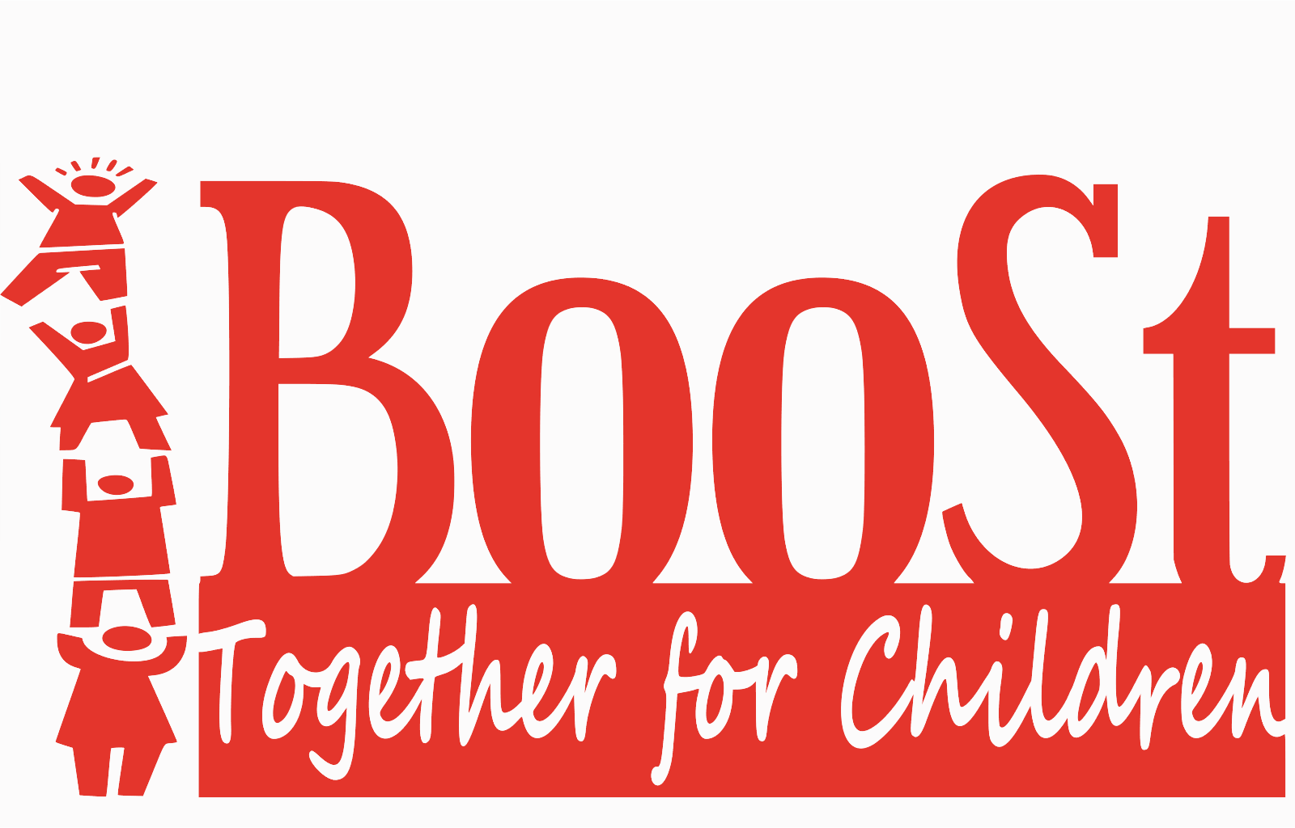

FY21 Annual Non-Profit Report Reported by: Nicole “Nikki” Fischer 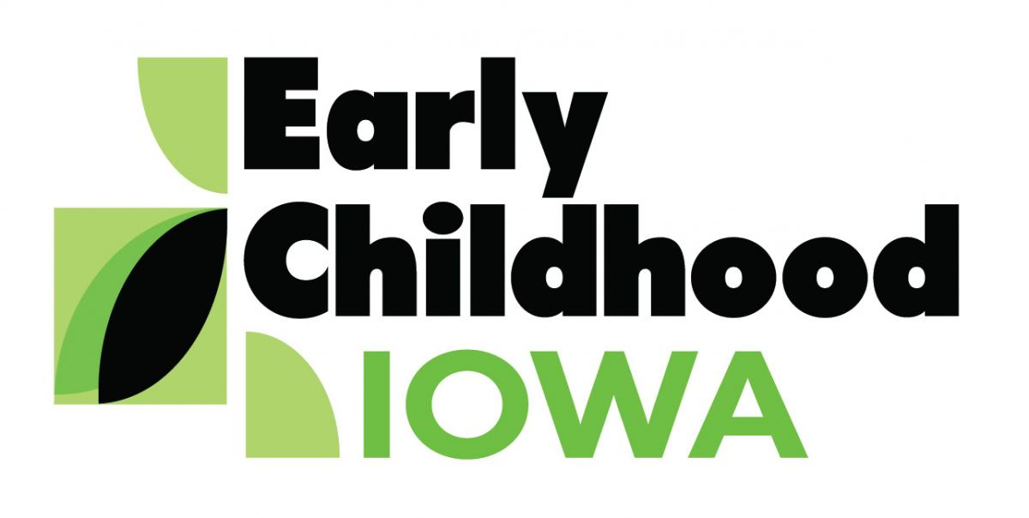
Table of Contents

Introduction 3
1. Executive Summary 4-5
2. Company Overview ……………………….6
3. Year End Financial Sheets 7-9
4. Financial Plan ……………………. 10-11

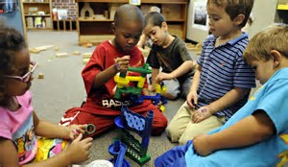
Introduction
BooSt Together for Children is the local area board for Early Childhood Iowa in Boone and Story Counties. We fund birth to five-year-old services such as home visiting, preschool scholarships, crisis care, training and consultation to improve the quality of child care. BooSt Together for Children envisions communities that have the capacity and commitment that leads to:
- Healthy Children
- Children Ready to Succeed in School
- Secure and Nurturing Child Care Environments
- Secure and Nurturing Families, and
- A Safe and Supportive Community
Goal: To work in collaboration with citizens to improve the lives of children and families in Boone and Story County.
Priorities: Providing, enhancing or expanding affordable, quality, accessible child care in:
  - Preschool Services
  - Home Visitations
  - Parent Support Services
  - Crisis Childcare

This annual review will include:
- Executive Summary
- Company Overview
- Year End Profit and Loss
- Operating Plan/Budget
- Financial Plan
- Contractors Year End Numbers
Executive Summary
BooSt Together for Children had another year of positive impact on their communities in Boone and Story County. The team worked through a tough year with a national pandemic continuing to impact the way the Non-Profit ran and impacted the communities we serve.
BooSt stayed in contact with their community through events, networking, and board meetings. The limits for events, and networking were still very much apart of the FY21 year, however we would like to highlight a few of them that were able to be completed.
BooSt was not able to partner with Ericson Public Library for their annual summer kickoff carnival, however, we were able to get some of the helmets from FY20 handed out in a drive by event. This event took place in Boone and was partnered with the Ericson Public Library’s Summer Reading Program. BooSt also made appearances at the library’s event “Singing in the Shade” concert to hand out helmets and activity kits. We look forward to bringing back the carnival next year, but are happy to provide safety and fun activities for the children of Boone.
Derecho was a big hit to all of our communities in early FY21. We partnered with CCR&R to provide grants to those that were affected. Together we were able to help 20 Child Development Homes and Licensed Centers or Preschools. There were 4 facilities that were able to obtain a 2nd grant. Each grant was from $500 to $1000, depending on the facility and if they had received the 1st round of funds. 467 children were impacted at the time of the grant within the Boone and Story County communities.

Here are some of the numbers for the year and where BooSt has been helping in the community.
From our Partners at CCR&R:
Number of programs served by type
12 | Non-registered
4 | Child Care Homes (accepting CCA)
3 | DHS registered
12 | DHS licensed
5 | DE regulated
36 | Total

From our Partners at LSI and their PAT program:
Number of Home Visits By County |  | Number of New Families Enrolled
137 | Boone | 10 | Boone
956 | Story | 41 | Story

From our Partners at MICA and our CCNC:
Number of programs participating with nurse consultant by QRS category
(A program may be counted more in more than one category)
 | QRS Level 1 |  | 5 | Non-Registered
 | QRS Level 2 |  | 54 | DHS Registered
3 | QRS Level 3 |  | 32 | DHS Licensed
12 | QRS Level 4 |  | 1 | DE Regulated/license exempt
5 | QRS Level 5 |  | 92 | Grand total
11 | # of children with special health care needs
379 | # of technical assistance contacts
48 | # of early learning programs participating in quality initiative

From our Partners at YSS:
 | Number of Home Visits By County |  | Number of New Families Enrolled
 | 67 | Boone | 26 | Boone
 | 216 | Story | 79 | Story

Company Overview
BooSt serves Boone and Story Counties including the following school districts: Ames, Boone, Collins-Maxwell, Colo-NESCO, Ballard, Gilbert, Madrid, Nevada, Ogden, Roland-Story and United. BooSt works alongside other services such as home visiting programs, Preschool Scholarship programs, and Child Care Training services in both Boone and Story County. Some of our contractors are Youth and Shelter Services, Mid Iowa Community Action, Lutheran Services in Iowa, and Child Care Resource and Referral.
- Company summary: BooSt Together for Children is the local area board for Early Childhood Iowa in Boone and Story Counties. We were formed in 2013 making the two counties one ECI Area and one Non-Profit, BooSt Together for Children. We fund birth to five-year-old services such as home visiting, preschool scholarships, crisis care, training and consultation to improve the quality of child care.
- Mission statement: The mission of the BooSt Together for Children Board is to help individuals and their communities improve the wellbeing of children, ages birth to 5, and their families
- Company history: Early Childhood Iowa began in 1998 as a statewide initiative to help communities improve the wellbeing and quality of life for children from birth through 5 years of age and their families. Boone and Story County collaborated efforts to form BooSt in 2013 and the ECI funds are administered by BooSt Together for Children, a not for profit corporation.
- Markets and services: All services from BooSt are serviced to Boone and Story County residence. Services include: Preschool Services, Home Visiting, Parent Support Services, and Crisis Childcare.
- Operational structure: BooSt Together for Children is a one-person office with our Area Director. The board consists of 10-17 volunteer members in the Boone and Story County community.
- Financial goals: The board and ECI Area Director use the guidelines provided to set strict budgets and award funds to programs in their area. BooSt works with a fiscal agent to help maintain proper accounting practices. The board reviews and approves all financials.

FY21 Year End Financial Sheets

EARLY CHILDHOOD STATE FUNDS UNDER EARLY CHILDHOOD IOWA
Early Childhood Iowa Area: Boone and Story County | FY20 | FY21
 | This column must match the final FY20 finanical statement submitted by the ECIA.
Revenues
Current allocation for Admin. ( not to exceed 5% of total award) for Reporting Year |  | $4,776.92
Program/Service Funds |  | $150,441.08
Subtotal current award |  | $155,218.00
Carry-forward from Previous Years available for current reporting year
Brought Forward-Administration |  | $1,103.63
Brought Forward -- Program/Service Funds |  | $11,158.93
Interest (Must be used in Program and not Administration)
Subtotal carryover funds |  | $12,262.56
Total Available funds |  | $167,480.56
Current Year Available Funds (Current Allocation plus Carry-forward) by Category
Admininistration (not to exceed 5% of total award) |  | $5,024.52
Program/Service Funds includes Carry-forward Interest |  | $162,456.14
Interest Earned During Current Fiscal Year |  | $162.88
Total Available funds by category including Interest Earned in Reporting Year |  | $167,643.54
Expenditures ( Reporting Year)
Administrative Expenditures (not to exceed 5% of total award)
Fiscal Agent fees
Liability Insurance fees
Financial Audit fees
Board Expenses
Association fees
Administrative Staff (ECIA director, support staff, etc.) |  | $7,162.28
Other |  | $233.50
Program/Service Expenditures |  | $151,142.37
Total Expenditures Reporting Year |  | $158,538.15
Unexpended Balance of Funds (Reporting Year)
Admininistration |  | -$2,371.26
Program/Service Funds |  | $11,476.65
Unexpended Balance of Funds (Reporting Year) |  | $9,105.39
Carry-Forward Percentage |  | 6%
FY'19 Amount over 20% into FY'20
FY'20 Amount over 35% into FY'21 (1-year only exception based on public health emergency) |  | $ -
Amount subject to 35% for FY'20 (1-year only exception based on public health emergency) and 20% for FY'21 Carryforward |  | $9,105.39
Maximum Allowable Carry-forward to next year (35% for SFY'20 and 20% for SFY'21 of total current award) |  | $31,043.60
Overage (Reduced from second succedding year payments) |  | $0.00

SCHOOL READY FUNDS UNDER EARLY CHILDHOOD IOWA
Early Childhood Iowa Area: | FY21
Revenues
Current allocation for Administration (not to exceed 3% of total award) for Reporting Year | $21,733.52
Quality Improvement Funds | $35,831.48
Other Programs/Services | $516,305.00
Subtotal current award | $573,870.00
Carry-forward from Previous Years: Available for Current Reporting Year
Brought Forward - Administration | $0.00
Brought Forward - Quality Improvement Funds | $5,160.46
Brought Forward - Other Programs/Services (includes interest applied) | $79,254.46
Subtotal Carry-forward funds | $84,414.92
Total Available funds | $658,284.92
Total Available Funds for Reporting Year
Administration (not to exceed 3% of total award) | $21,733.52
Quality Improvement Funds | $35,831.48
Other Programs/Services | $528,943.99
Interest Accrued in Current Fiscal Year (Must be used in Program and not Administration) | $778.23
Grand Total Budget for Reporting Year | $587,287.22
Expenditures (Reporting Year)
Administration Expenditures (not to exceed 3% of total award)
Fiscal Agent fees | $2,049.88
Liability Insurance fees | $1,232.13
Financial Audit fees | $1,989.00
Board Expenses | $233.50
Association fees
Administrative Staff (ECIA director, support staff, etc.) | $21,733.52
Other | $1,973.21
Quality Improvement Funds | $35,831.48
Other Programs/Services includes Interest Applied | $411,325.84
Grand Total Expenditures for Reporting Year | $476,368.56
Unexpended Balance of Funds for Reporting Year (Becomes Carry-forward in 1st succeeding year)
Administration (not to exceed 3% of total award) | $0.00
Quality Improvement Funds | $0.00
Other Programs/Services includes Interest Applied | $195,333.58
Unexpended Balance of Funds (Reporting Year) | $195,333.58
Carryforward Percentage | 34%
FY'19 Amount over 20% into FY'20
FY'20 Amount over 35% into FY'21 (1-year only exception based on public health emergency) | $0.00
Amount subject to 35% for FY'20 (1-year only exception based on public health emergency) and 20% for FY'21 Carryforward | $195,333.58
Maximum Allowable Carry-forward to next year (35% for SFY'20 and 20% for SFY'21 of total current award) | $114,774.00
Overage (Reduced from second succeeding year payments) | $80,559.58

FY22 Financial Plan, Looking Ahead
BooSt FY22 Chart of Accounts
Category |  | Program/Service | Entity | SR FY22 Funds
SR Admin |  | Director Sal (11.86%) | Staff (1 of 3) | 5,474
 |  | FICA | 1 of 3 | 332
 |  | IPERS | 1 of 3 | 525
 |  | Health and Disability | 1 of 3 | 2,000
 |  | Office Supplies 100% |  | 11,348
 |  | Audit/ board exp. | various | 2,200
 |  | PR/Web 100% |  | 1,200
 |  | Mileage 100% |  | 500
 |  | Phone 100% |  | 600
 |  | FiscalAgent3%salben | Story County | 2,320
 |  | Training/Conf 100% |  | 1,500
 |  | Liability Ins. 100% | ICAP | 1,300
 |  |  | Subtotal admin | 29,299
Quality |  | Director Sal (78.45%) | Staff 2 of 3 | 35,374
Improvement |  | FICA | 2 of 3 | 2,468
378-47 |  | IPERS | 2 of 3 | 3,525
 |  | Health Insurance | 2 of 3 | 14,102
 |  | Mini Grants | various | 2,002
 |  |  | Subtotal QI | 57,471
SR Other |  |  | Agency
366-47 |  | PK Scholarships | various | 114,000
 |  | Storks Nest | YSS | 52,000
 |  | Mini Grants | various | 54,526
 |  | Healthy Futures | YSS | 113,600
 |  | Parents as Teachers | LSI | 196,634
 |  |  | Subtotal Other | 530,760
 |  |  | SubSRPrograms | 588,231
Early Childhood FY20 Billing Codes |  |  | SR Total | 617,530
Category |  | Program/Service | Agency
EC Admin |  | Director Sal 9.69% | 3 of 3 | 5,145
 |  | FICA | 3 of 3 | 325
 |  | IPERS | 3 of 3 | 490
 |  | health In | 3 of 3 | 1,927
 |  |  | Subtotal EC adm | 7,887
EC Programs |  | Crisis Child Care | LSI | 41,600
 |  | Childcare Consultation | Orchard Place | 46,244
 |  | CCNC MICA | MICA | 42,781
 |  | Mini Grants | various | 29,356
EC interest |  | 157739 | Subtotal EC CC | 159,981
SR interest |  | 571451 | EC Total | 167,868
EC carry forward |  |  | SR Total | 617,530
SR carry forward |  |  | Total Budget | 743,711

